## 

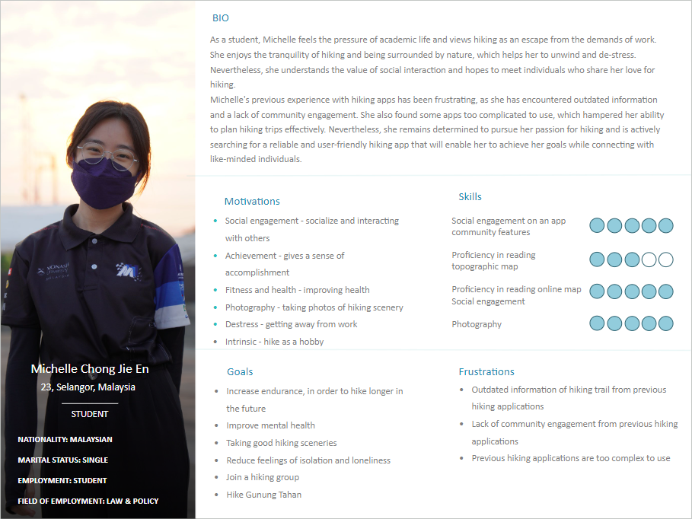

**User Stories**

| Priority | User Stories | Justification |
| --- | --- | --- |
| Must Have | * As Robert, I want to be able to search and discover hiking trails, so that I can trail that suits my needs      * As Robert, I want to look at maps, so that I can navigate through the a hiking trail * As Michelle, I want to be able to chat with other users, so that I can have some social interactions * As Michelle, I want to be able to monitor my hiking performance, so that I know what’s my hiking progress | Users' preferences and needs for hiking vary, including difficulty level, terrain, distance, and location. A search and discovery feature can personalise the app for users like Robert, allowing him to find trails that meet his criteria.  A map feature can enhance safety and enjoyment by helping users navigate and discover new routes.  Social interaction, through a chat feature, can foster connections and a sense of community, increasing engagement.  Tracking hiking performance metrics, such as distance, time, and elevation, can provide motivation and a sense of achievement for users like Michelle, improving the app's effectiveness.  Adding these features is necessary because they fulfil the basic needs of a hiking trail app. For hikers like Robert and Michelle, the search and discovery feature, map, chat function, and performance tracking are essential components for a personalised and safe hiking experience. |
| Should Have | * As Michelle, I want to be able to look for hiking groups, so that I can join a hiking group * As Michelle, I want to have notifications feature, so that I can have timely information from the app | Socialising is crucial for hikers like Michelle. A group feature would enable her to connect with other hikers, exchange tips, and make friends with common interests, increasing the app's engagement and value.  Notifications provide crucial information for a safe and enjoyable hike, such as weather alerts, trail closures, and group events. This enhances the app's effectiveness and value for Michelle. |
| Could Have | * As Robert, I want to alert other user of any danger, so that users can avoid danger * As Robert, I want to adjust font sizes on the app, so that I can see the words clearer * As Michelle, I want to be able to change app’s language, so that I could use a language that I am more familiar with | Robert can report hazards on the trail through the app, which informs other users to navigate the trail safely. This feature promotes community and responsibility among hikers.  Customization is key for both Robert and Michelle. Robert can adjust the font size to his preference, making the app more accessible to users with visual impairments or accessibility needs. Michelle can change the app's language to one she is more familiar with, making it easier for her to navigate the interface and understand the features. Both features enhance the app's inclusivity and improve the user experience for Robert and Michelle. |
| Won’t Have | * As Robert, I want to be able look for hiking supplies, so that I can buy * As Michelle, I want to add hiking notes, so that I can look back on those in the future | Our decision is to exclude the feature of searching for hiking supplies in the app. Instead, we concentrate on offering a platform to explore and find hiking trails rather than selling hiking gear. While we recognize the importance of having the right gear for a safe and enjoyable hike, we believe that users can easily find and purchase hiking supplies through other online marketplaces or retail stores.  Regarding the option to add hiking notes, we acknowledge the usefulness of being able to take personal notes on hiking experiences, but we have opted not to incorporate this feature in order to keep the app simple and efficient. Instead, we recommend that users utilise external note-taking apps or tools to document their own notes and reflections on their hiking adventures. |

**Additional Requirements**

1. Allows users to plan hikes with other users

The hiking trail app feature that enables users to organize hiking trips with other users considers critical factors such as trail difficulty, weather, and timing when selecting the route and setting the date and time. Tools such as sharing trail information and setting meeting points are available to simplify coordination between users, promoting a collaborative hiking experience that encourages social interaction and group formation. Users can invite others to join them on a hike through the app, and Google Calendar invitations can be sent to ensure everyone is on the same page regarding the hike details. These features make it simple and convenient for hiking enthusiasts to plan and coordinate hikes with others using the app.

1. Allows users to communicate with other users

A feature in a hiking trail app that enables users to interact and communicate with each other. This feature can consist of a messaging system, chat function, or forum where users can exchange information and tips about hiking, discuss related topics, and plan hiking trips. Through this communication feature, users can form connections, explore new hiking trails, and arrange group activities or hikes.

**Individual Analysis/Reflection**

I have developed two user personas named Robert and Michelle, derived from the information we gathered from the identified persona groups. These personas help us understand the target audience for the hiking trail app, their goals and behaviours when using such apps, and provide valuable user perspectives. By utilising these insights, my team can gain a competitive advantage and position the app ahead of its competition.

The two user personas, Robert and Michelle, are based on the "Community hikers" persona group, which comprises casual and experienced hikers who enjoy sharing their hiking experience with others. This group prefers to hike with family and friends as they are motivated to hike to socialise and interact with others. By understanding the needs and behaviours of this persona group, our team can create a hiking trail app that caters to their preferences, providing a competitive edge in the market.

Robert is a 27-year-old Malaysian male and full-time employee who enjoys hiking as a way to improve his physical and mental health and escape from the demands of work and city life. He values social interaction and hopes to connect with like-minded individuals through hiking. These observations are based on the responses of four Chinese Malaysian workers who also prefer to hike with family and friends. Robert represents a larger group of individuals who are motivated to hike for their health benefits. Among these respondents, 50% have encountered limitations with previous hiking apps due to outdated information on hiking trails. Like others in this group, Robert hopes to have a reliable and updated hiking app to help him plan his trips and achieve his goals. Therefore, it would be beneficial for our app to include a feature that allows users to plan hiking trips and connect with other like-minded individuals.

Michelle is a 23-year-old Chinese female student who considers hiking as an escape from academic pressure and a way to destress. She represents 7% of the respondents who are female students and want to improve their health. Michelle enjoys the tranquility of hiking, but she also hopes to connect with like-minded individuals. In fact, within the 7% of respondents who are female students, a significant number are motivated to hike for social interaction, a motivation shared by 22% of all respondents. Unfortunately, Michelle has had frustrating experiences with previous hiking apps, which lacked updated information and community engagement. She is looking for a reliable and user-friendly app that will help her plan hiking trips effectively and connect with other like-minded individuals. Therefore, implementing a feature that allows individuals like Michelle to communicate with others who share her passion for hiking is essential.